Lab Exercise 1: Event Handling

Solution:-

.xml file

<LinearLayout xmlns:android="http://schemas.android.com/apk/res/android"  
 xmlns:tools="http://schemas.android.com/tools"  
 android:layout_width="match_parent"  
 android:layout_height="match_parent"  
 android:orientation="vertical"  
 android:padding="16dp"  
 tools:context=".MainActivity">  
 <EditText  
 android:id="@+id/editText"  
 android:layout_width="match_parent"  
 android:layout_height="wrap_content"  
 android:hint="Enter Text" />  
 <Button  
 android:id="@+id/button"  
 android:layout_width="wrap_content"  
 android:layout_height="wrap_content"  
 android:text="Click Me" />  
</LinearLayout>

.kt file

package com.example.eventhandlingdemo  
import android.os.Bundle  
import android.widget.Button  
import android.widget.EditText  
import android.widget.Toast  
import androidx.appcompat.app.AppCompatActivity  
class MainActivity : AppCompatActivity() {  
 override fun onCreate(savedInstanceState: Bundle?) {  
 super.onCreate(savedInstanceState)  
 setContentView(R.layout.activity_main)  
 val editText: EditText = findViewById(R.id.editText)  
 val button: Button = findViewById(R.id.button)  
 button.setOnClickListener **{** val text = editText.*text*.toString()  
 Toast.makeText(this, "You entered: $text", Toast.*LENGTH_SHORT*).show()  
 **}** }  
}

output

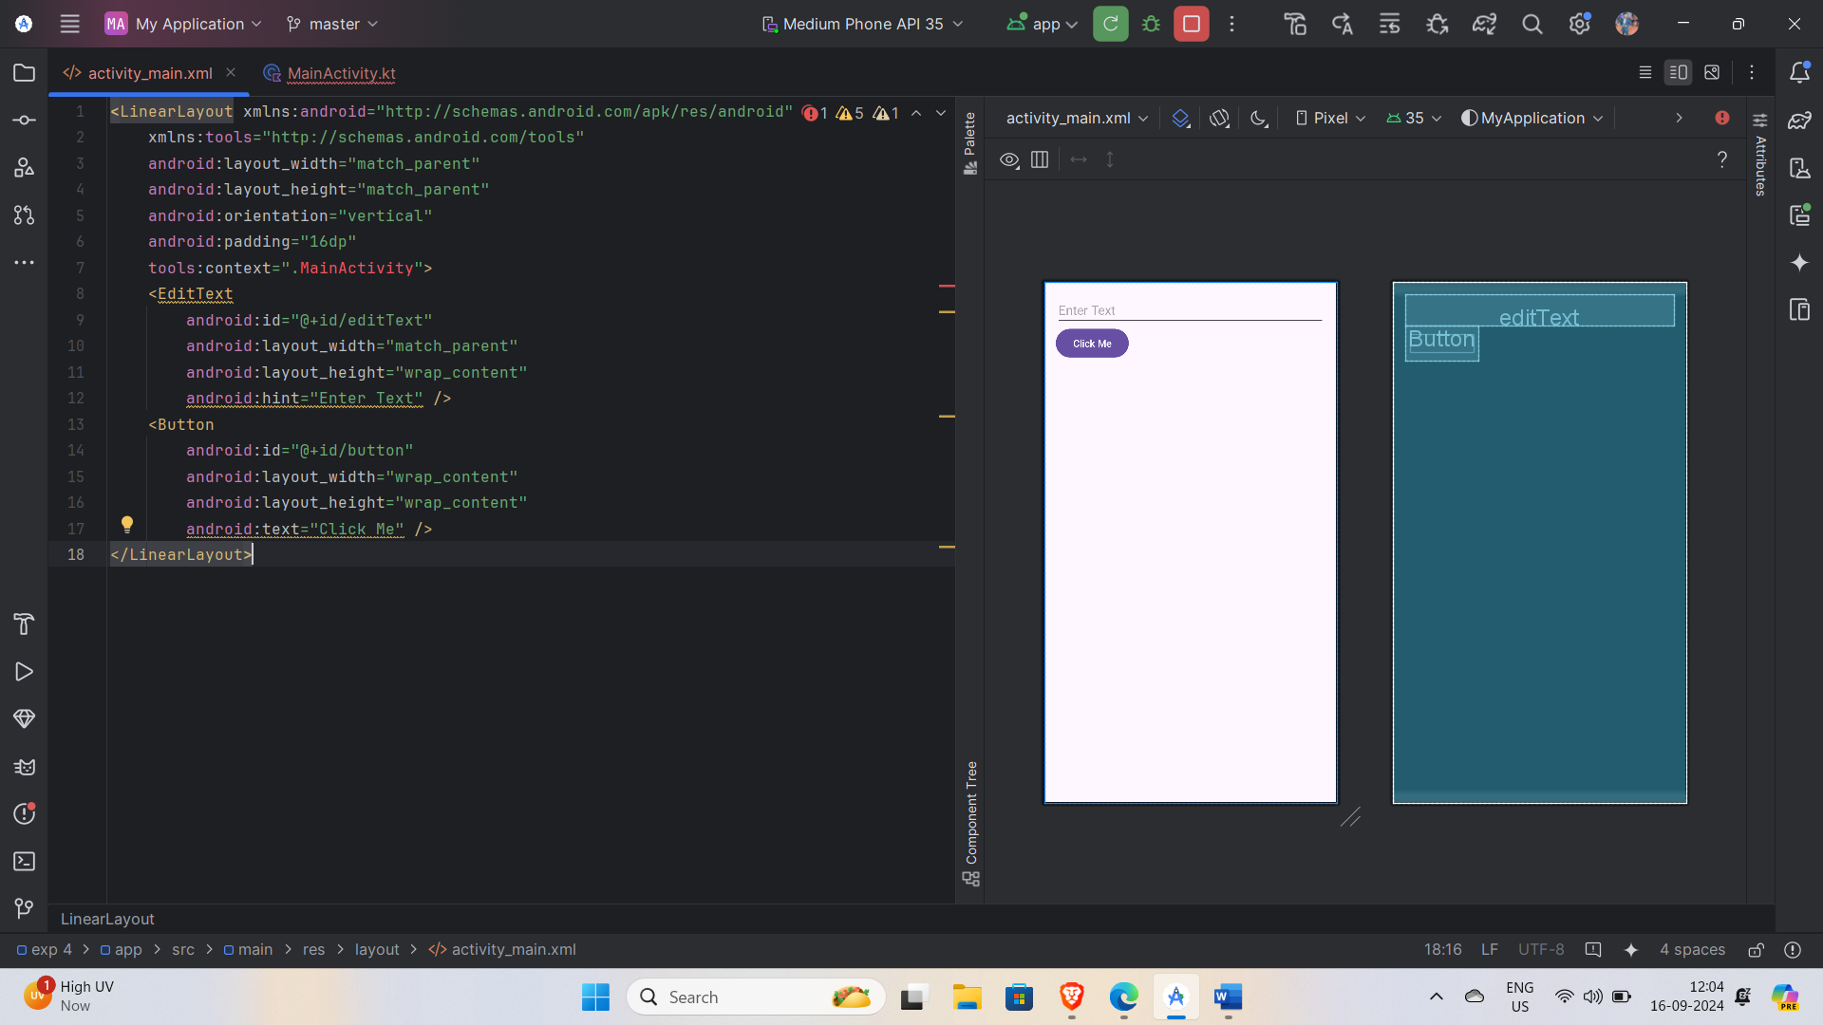

Lab Exercise 2: Toast Notification

Solution:-

.xml file

<?xml version="1.0" encoding="utf-8"?>  
<androidx.constraintlayout.widget.ConstraintLayout xmlns:android="http://schemas.android.com/apk/res/android"  
 xmlns:app="http://schemas.android.com/apk/res-auto"  
 xmlns:tools="http://schemas.android.com/tools"  
 android:id="@+id/main"  
 android:layout_width="match_parent"  
 android:layout_height="match_parent"  
 android:background="#E9DEDE"  
 tools:context=".MainActivity">  
  
 <TextView  
 android:id="@+id/mytextView"  
 android:layout_width="wrap_content"  
 android:layout_height="wrap_content"  
 android:text="Hello World!"  
 android:textColor="#1B1A1A"  
 android:textColorHighlight="#F0ECEC"  
 android:textSize="60sp"  
 app:layout_constraintBottom_toBottomOf="parent"  
 app:layout_constraintEnd_toEndOf="parent"  
 app:layout_constraintStart_toStartOf="parent"  
 app:layout_constraintTop_toTopOf="parent"  
 app:layout_constraintVertical_bias="0.522" />  
  
 <Button  
 android:id="@+id/my_button"  
 android:layout_width="143dp"  
 android:layout_height="74dp"  
 android:text="ClickME"  
 android:textColor="#EBE3E3"  
 android:textColorHighlight="#F0ECEC"  
 android:textSize="20sp"  
 app:layout_constraintBottom_toBottomOf="parent"  
 app:layout_constraintEnd_toEndOf="parent"  
 app:layout_constraintHorizontal_bias="0.059"  
 app:layout_constraintStart_toStartOf="parent"  
 app:layout_constraintTop_toTopOf="parent"  
 app:layout_constraintVertical_bias="0.243" />  
</androidx.constraintlayout.widget.ConstraintLayout>

Output

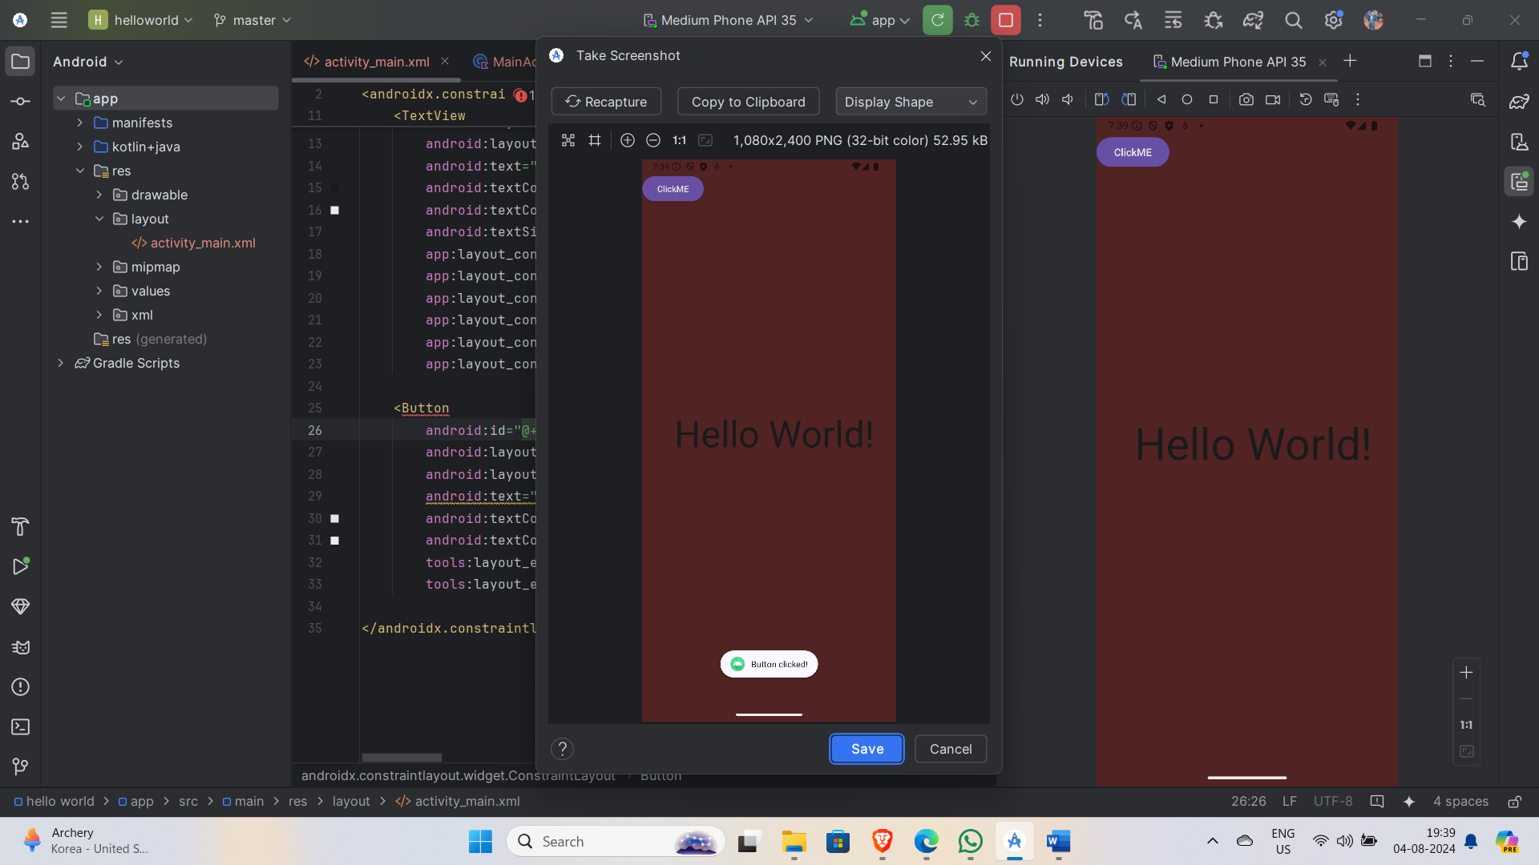

Lab Exercise 3: AlertDialog

Solution:-

.xml file

<?xml version="1.0" encoding="utf-8"?>  
<LinearLayout xmlns:android="http://schemas.android.com/apk/res/android"  
 xmlns:tools="http://schemas.android.com/tools"  
 android:layout_width="match_parent"  
 android:layout_height="match_parent"  
 android:orientation="vertical"  
 android:padding="16dp"  
 tools:context=".MainActivity">  
  
 <EditText  
 android:id="@+id/editText"  
 android:layout_width="match_parent"  
 android:layout_height="wrap_content"  
 android:hint="Enter Text" />  
  
 <Button  
 android:id="@+id/button"  
 android:layout_width="wrap_content"  
 android:layout_height="wrap_content"  
 android:text="Show Dialog" />  
</LinearLayout>

.kt file

package com.example.eventhandlingdemo  
  
import android.os.Bundle  
import android.widget.Button  
import android.widget.EditText  
import android.widget.Toast  
import androidx.appcompat.app.AlertDialog  
import androidx.appcompat.app.AppCompatActivity  
  
class MainActivity : AppCompatActivity() {  
  
 override fun onCreate(savedInstanceState: Bundle?) {  
 super.onCreate(savedInstanceState)  
 setContentView(R.layout.activity_main)  
  
 val editText: EditText = findViewById(R.id.editText)  
 val button: Button = findViewById(R.id.button)  
  
 button.setOnClickListener **{** showAlertDialog(editText.*text*.toString())  
 **}** }  
  
 private fun showAlertDialog(text: String) {  
 // Create the AlertDialog builder  
 val builder = AlertDialog.Builder(this)  
  
 // Set the title and message of the dialog  
 builder.setTitle("Alert")  
 builder.setMessage("You entered: $text")  
  
 // Add a positive button  
 builder.setPositiveButton("OK") **{** dialog, _ **->** dialog.dismiss() // Close the dialog when the button is clicked  
 **}** // Optionally add a negative button  
 builder.setNegativeButton("Cancel") **{** dialog, _ **->** dialog.dismiss() // Close the dialog when the button is clicked  
 **}** // Create and show the AlertDialog  
 val alertDialog = builder.create()  
 alertDialog.show()  
 }  
}

output

